2.1 Prof. Dr. Immacolata Amodeo

Main Research Interests

- Comparative Literature
- Comparative Media Studies
- Literary and Cultural Theory
- Intercultural and Transcultural Studies
- Literature in its Relations to other Media (mainly Opera, Music, and Film)
- Multilingualism and Literature
- Migration and Literature
- Aesthetic Aspects of Cultural Conflicts and Cultural Encounters

Research Activities

Immacolata Amodeo has been working on the book version of her German Habilitationsschrift which now is published under the title Das Opernhafte (2007). Furthermore, she has picked up one of her former research interests, Italian colonialism, particularly Italian colonial film, and presented the results of this research at the Romanistentag 2007 in Vienna. In addition, she has worked on intercultural aspects of 18th century German culture choosing as a case study the Court of Margrave Wilhelmine of Bayreuth, and on aspects of globalization choosing as a case study a collection of folk songs of the Albanophone minority in South Italy. She has continued and diversified her research activities in the field of migrant literatures, and presented the results in lectures given in Italy and Germany, and in papers at conferences in France. The research on migrant literature in Germany lead, as far as publications are concerned, to the translation (from the German to the Italian) of and edition of a collection of short-stories by the author of Italian origin Franco Biondi living in Germany and writing in German. It lead, on a more practical note, to the organization of the "globale°- Festival für grenzüberschreitende Literatur" (in cooperation with Radio Bremen), fully third-party funded.

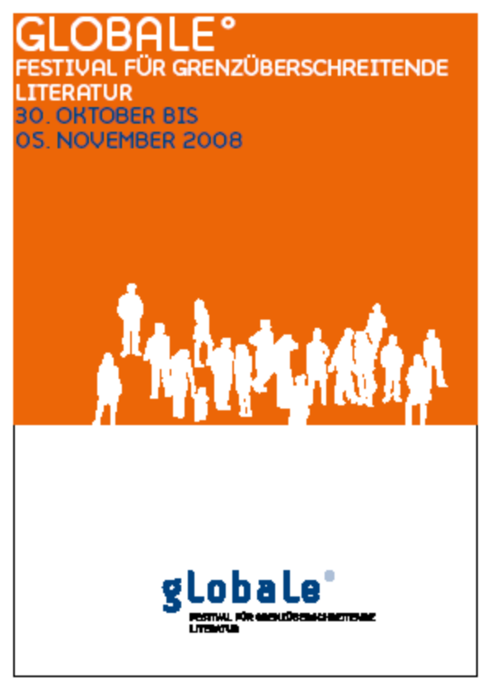

Organization of Scientific Conferences

November 2007
Shakespeare Company, Bremen
globale° – Festival für transkulturelle Gegenwartsliteratur
Funded by Robert Bosch Stiftung
120 international participants

June 2008
Weserburg Museum für moderne Kunst, Bremen
Radio as Art. Kontexte der Radiokunst (organized together with Anne Thurmann-Jajes)
Funded by Stiftung Kulturfonds, Instituto Cervantes Bremen, Studienzentrum für Künstlerpublikationen Weserburg Museum für moderne Kunst Bremen
30 international participants
Proceedings: in process

Oktober / November 2008
Jacobs University Bremen, Radio Bremen, Literaturcafé Ambiente, Volkshochschule Bremen, Auswandererhaus Bremerhaven, Medienarchiv Günter Grass Stiftung Bremen, Zentral-bibliothek Bremen
globale° - Festival für grenzüberschreitende Literatur
Funded by Bremen, Stadt der vielen Kulturen; Bremer Literaturstiftung; Bremer Literaturkontor; Deutsch-Japanische Gesellschaft zu Bremen e.V. (Wolfgang Haas); Deutsches Auswandererhaus Bremerhaven; Kaefer Isoliertechnik; Kulturamt Bremerhaven; Medienarchiv Günter Grass Stiftung Bremen; PWC-Stiftung; Radio Bremen; Robert Bosch Stiftung; Senatorin für Arbeit, Frauen, Gesundheit, Jugend und Soziales Bremen – Zuwandererangelegenheiten und Integrationspolitik; Senator für Kultur Bremen; START-Stiftung; workshop literature e.V.; Waldemar Koch Stiftung
1.000 international participants
Proceedings: in process (Ulrike Helmer Herlag, 2009)

Other Professional Activities

- Reviewing for foundations and other institutions (Alexander von Humboldt Foundation, Studienstiftung des Deutschen Volkes, DAAD etc.)
- Member of the jury for the International Literature Prize "Albatros" of the Medienarchiv Günter Grass Stiftung Bremen; INPUTS (Institut für postkoloniale und transkulturelle Studien, Universität Bremen); Scientific Board of the Studienzentrum für Künstlerpublikationen (Research Centre for Artists’ Publications), Weserburg-Museum für moderne Kunst, Bremen; Scientific Advisory Board of the Research and Exhibition Project "FrauenWelten. Zur Veränderung weiblicher Arbeits- und Lebenswelten in der Migration", Kultur Rhein-Neckar e.V.
- Coordinator (together with Prof. Dr. Nicola Spakowski till Aug. 2008, together with Prof. Dr. Brendan Dooley since Sept. 2008) of the Humanities Graduate Programm "Intercultural Humanities", Jacobs University Bremen
- Extern examiner for German, National University of IreIand, Galway
- Visiting professorship, Leopold-Franzens-Universität Innsbruck, academic year 2007/2008
- Collaboration within the cooperative project "Citoyenneté, compétences et culture/s en Europe", application Comenius (cooperation partners: Università di Pavia, Università La Sapienza di Roma, Universidad de Valencia, Universitdad de Castilla – La Mancha, Ecole Normale Supérieure de Cachan and others), Lifelong Learning Programme

PhD-Students

Maaheen Ahmed
A trans-border typology for graphic novels

Heidrun Gudrun Hörner
China’s New Literature is Taking Place Abroad: How Authors of Chinese Origin in France and Germany Write – A Comparative Analysis

Christiane Kiemle
Ways out of Babel: Linguistic and Cultural Aspects of Migrant Literature in Italy

Brigitte Kienle
On "New World Literatures": Globalization and Aesthetics in the Literature of Migrant African Authors in Italy

Philipp Somrowsky
REBEL ART. Das Kunstprojekt des Vortizismus (Universität Bayreuth)
Defense: January 2007

